ECE Senior Design Weekly Report

**Engineer’s Name:** Leon Tran             **Date:** 04/12/17

**Team Name:** The Globetrotters **Lab Section:** 4

**Week’s Task:** Redesigning the GUI, adding additional displays and features, and getting measurements for the different positions of the Hall Effect Sensors

**Results:**

* **GUI**
  + Converted Map from Map Box back to Google maps due to performance issues on the PI during map animations
  + New GUI Design

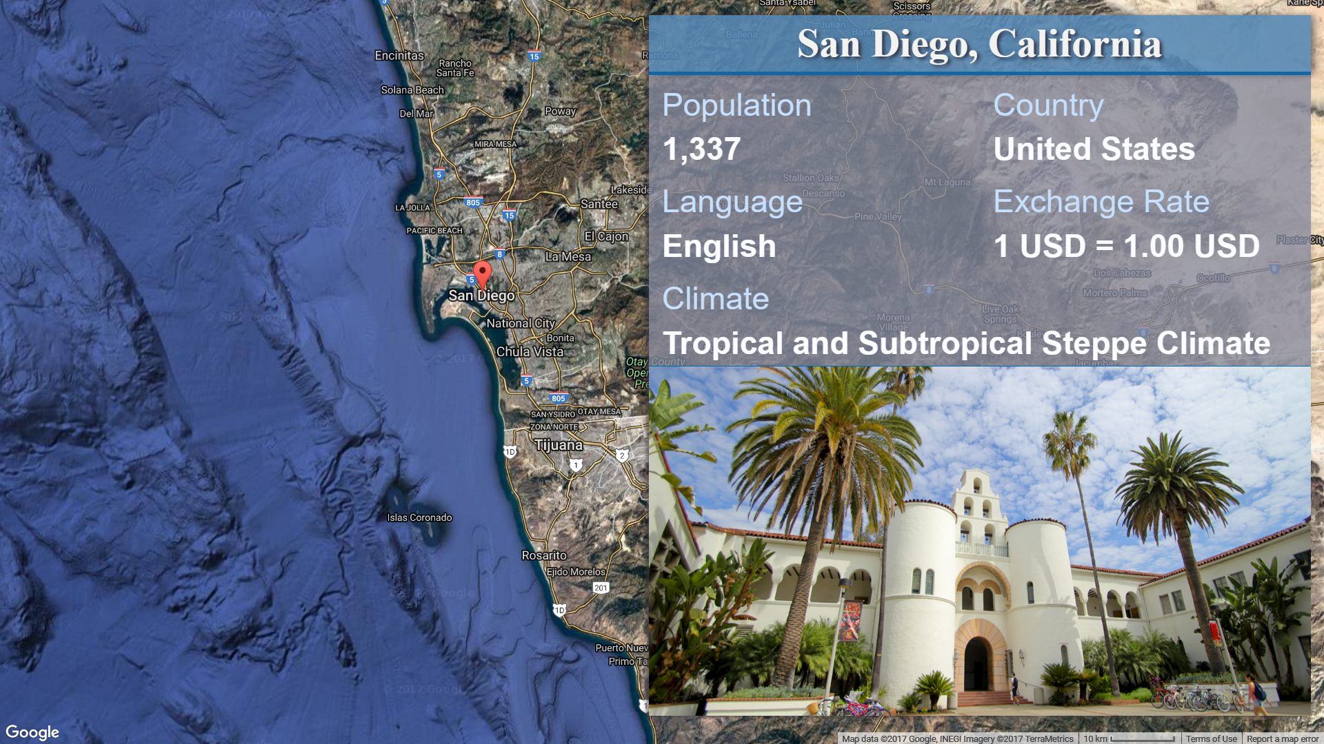

* + Added extra details for each location, a help screen, and info about the design of the project
* **Hall-Effect Sensors Reading**
  + Chris & I did some testing regarding the orientation and positioning of the sensors on the coils.

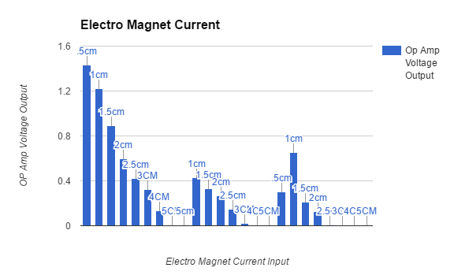

* + Testing was conducted at 1A, 2A, & 3A. Because we tested it with those currents over an extended period of time, the result was skewed as a result of exceeding the map temperatures for the Hall Effect Sensors